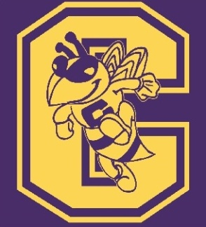 CHICOD PTA MEMBERSHIP
Welcome back to a new school year! We would love for you to join the PTA! Chicod PTA has been able to support students and staff in the following ways: Minigrants, Chrome Books, Ipads, books, first aid kits, microwaves, etc. In addition PTA provides teacher and student support while encouraging learning in the classroom. Without your support, we will not be able to make these things happen. *Remember anyone can join: teachers, parents, grandparents, community members.* Your involvement can be as little or as much as you would like. We appreciate your support of the school by joining your PTA. To join the PTA, complete this form and return it along with $10.00 (per family) to your child’s teacher. 2016-2017 Membership Dues include a Chicod Hornets Window Decal! This year we are even giving you the option to purchase a Chicod PTA shirt. They are $10 each and come in sizes Adult S-XL. Show your school pride by joining today!

Parent(s)____________________________________Phone_____________________

Membership Only $10______________

Shirts (Optional) $10 each – Quantity _____________ Size(s)____________

Please make checks payable to: Chicod PTA

Are you available during school hours? Yes____No___Best time to contact_________

Email_________________________________________________________________

Be sure to join our “Chicod PTA 2016-2017” Facebook page!

Child’s Name:_______________________________ Grade ______Teacher: ___________________
Child’s Name:_______________________________ Grade ______Teacher: ___________________
Child’s Name:_______________________________ Grade ______Teacher: ___________________
Child’s Name:_______________________________ Grade ______Teacher: ___________________
Child’s Name:_______________________________ Grade ______Teacher: ___________________

Please see our Volunteer Opportunities form if you are interested in becoming more involved. The form is located on the Chicod PTA website, or you can call, email, or even send us a message on our Facebook page!

